Practical 21 Creating Graphs

Adding a new library to a project
Today we will create graphs using an imported chart library. For details on JFreeChart please check the following link. http://www.jfree.org/jfreechart/
In Eclipse create a project with a tabbed pane GUI. We will be creating extra tabs for our gui at run-time.
If the libraries should be distributed with your project, you can store the JAR files directly in your project, this is what we will do.
For example, you can create a new Java project. Then create a new folder called lib by right-clicking on your project and selecting New → Folder.
From the menu select File → Import → General → File System. Select the Java library you want to import and select the lib folder as target. Alternatively, just copy and paste the jar file into the lib folder.
Navigate to BITY2\IN610 Java\Week 12\ folder
You only need the following library.
• jfreechart-1.5.0.jar
To manage your classpath, right-click on your project and select Properties. Under Java Build Path → Libraries-Classpath select the Add JARs button, navigate to the lib folder and select the files and hit Apply.
The following example shows how the result would look like if the jar files have been added to the project.
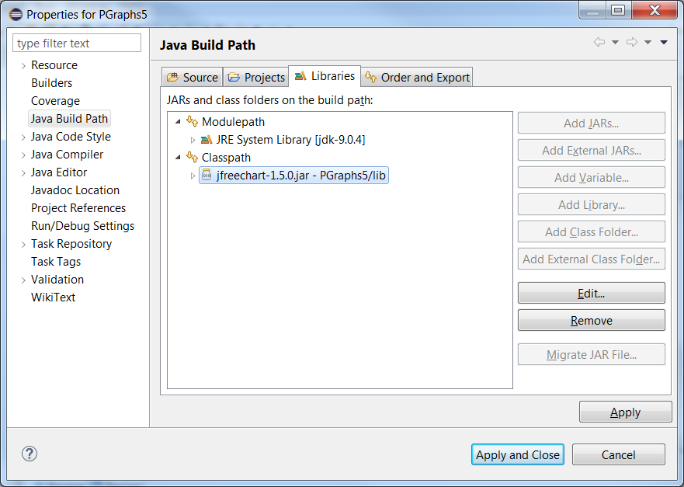
After adding it to the classpath, Eclipse allows you to use the classes contained in the JAR file in the project. Outside Eclipse you still need to configure your classpath, e.g., via the MANIFEST.MF file.
- Create a Pie chart using your own data, the createPieChart method accepts
title - the chart title (null permitted).
dataset - the dataset for the chart (null permitted).
legend - a flag specifying whether or not a legend is required.
tooltips - configure chart to generate tool tips?
locale - the locale (null not permitted).

Note: the following methods are called from the gui’s constructor

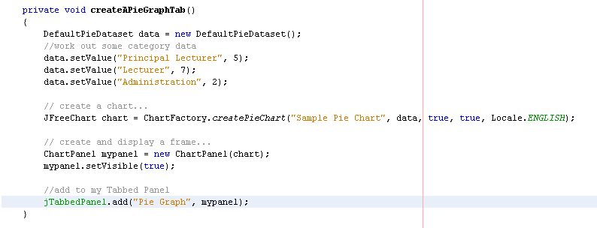
- Create an XY line graph using your own data. You can have more than one series, the createXYLineChart method accepts:
title - the chart title (null permitted).
xAxisLabel - a label for the X-axis (null permitted).
yAxisLabel - a label for the Y-axis (null permitted).
dataset - the dataset for the chart (null permitted).
orientation - the plot orientation (horizontal or vertical) (null NOT permitted).
legend - a flag specifying whether or not a legend is required.
tooltips - configure chart to generate tool tips?
urls - configure chart to generate URLs?

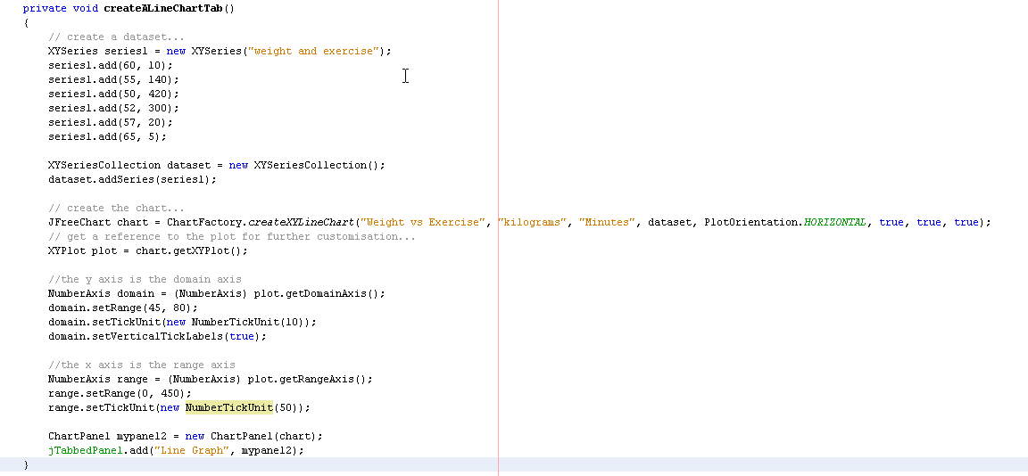
- Create a bar graph using your own data, add another series by entering another string as the middle value in the addValue method.
Parameters:
title - the chart title (null permitted).
categoryAxisLabel - the label for the category axis (null permitted).
valueAxisLabel - the label for the value axis (null permitted).
dataset - the dataset for the chart (null permitted).
orientation - the plot orientation (horizontal or vertical) (null not permitted).
legend - a flag specifying whether or not a legend is required.
tooltips - configure chart to generate tool tips?
urls - configure chart to generate URLs?

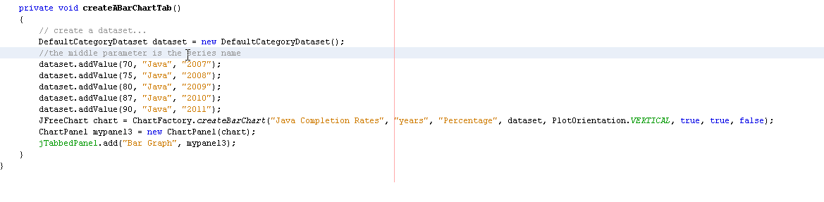
- Create a graph of your choice for your assignment 1 project, check the JavaDocs for the ChartFactory class to see a list of over 20 chart types.

